1. Install Wordpress in Local Host

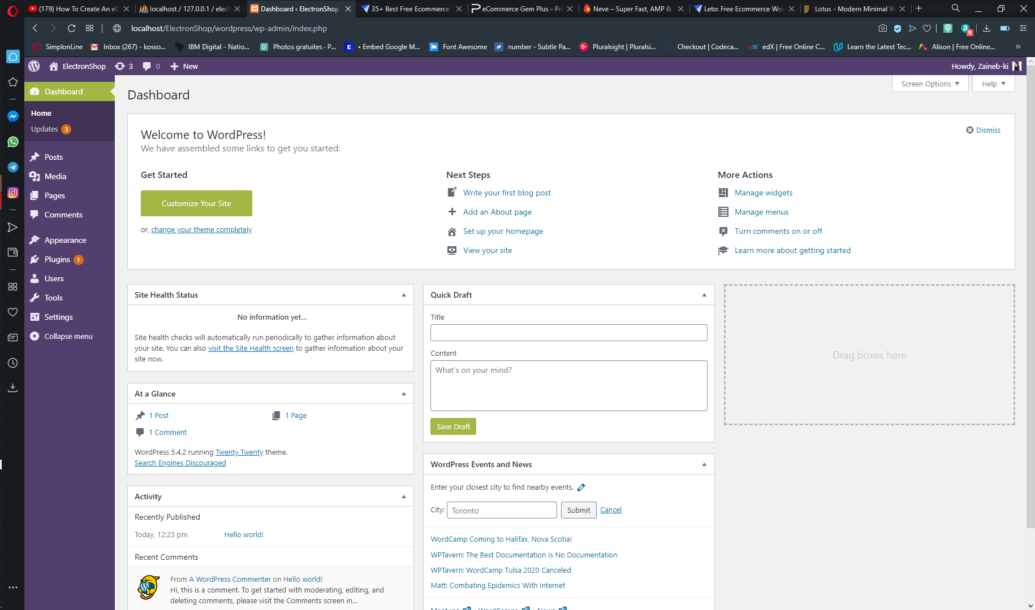

1. Next step, we’ll install some plugin that we need it Like Astra

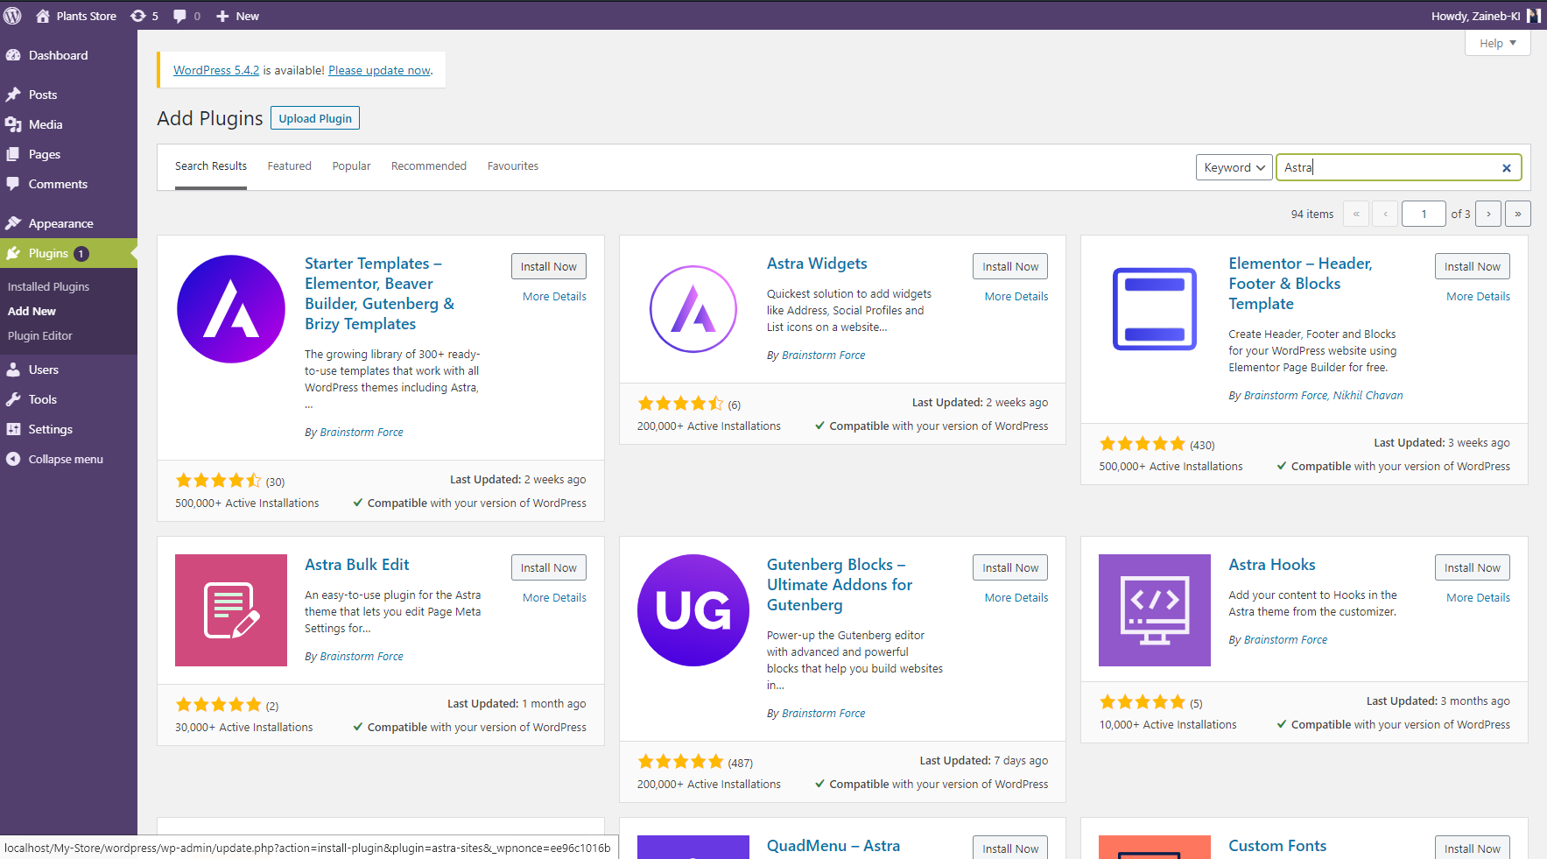

1. And also, a Plugin named ‘Elementor’ that can help us to edit our themes

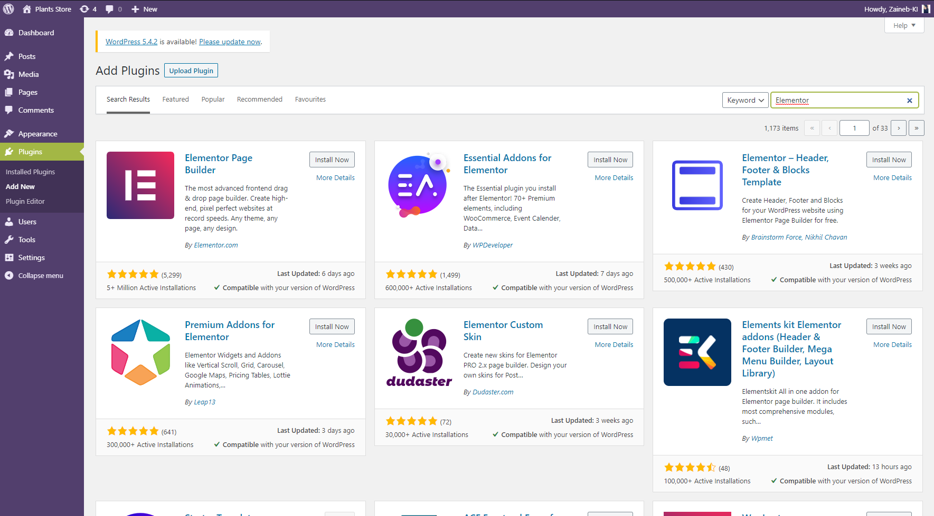

1. We should activate our plugins

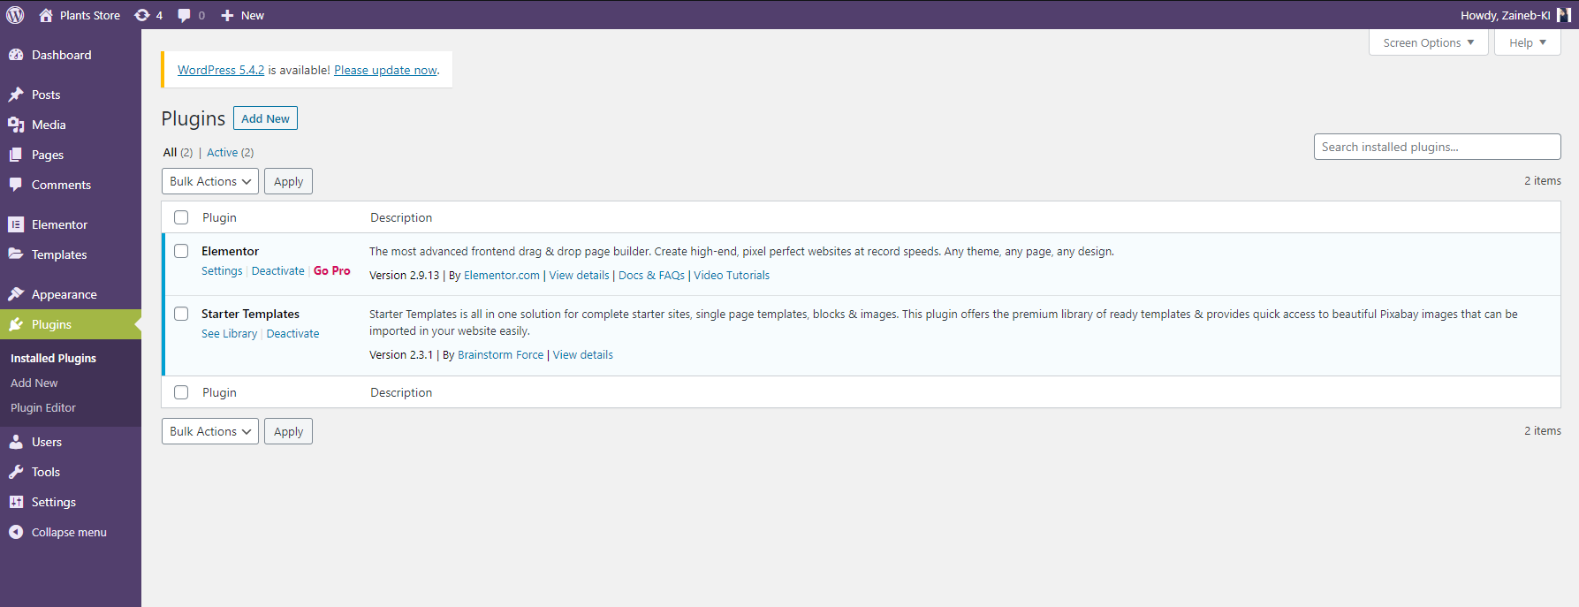

1. After that, we go to Appearance -> starter templates -> Select the Builder ‘Elementor’

And update a template as we like

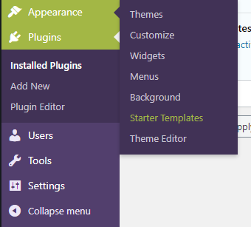

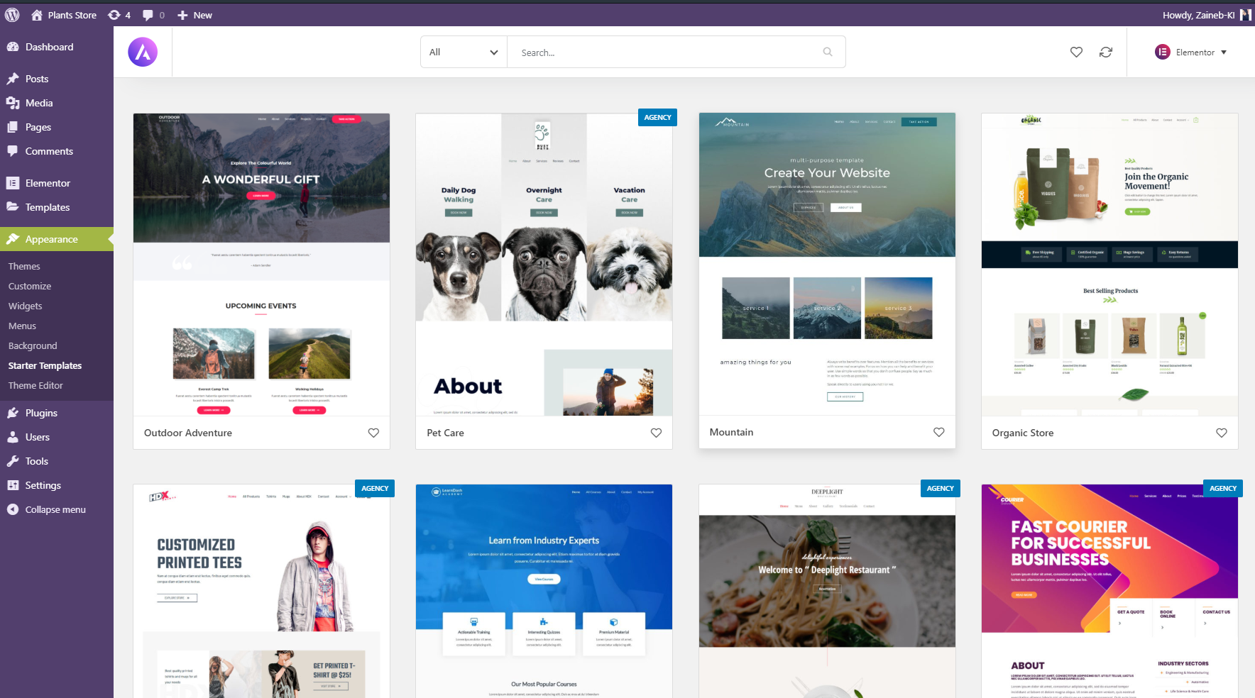

1. I have choosing this template because I will sell the Plants, so let’s start our Project ^^

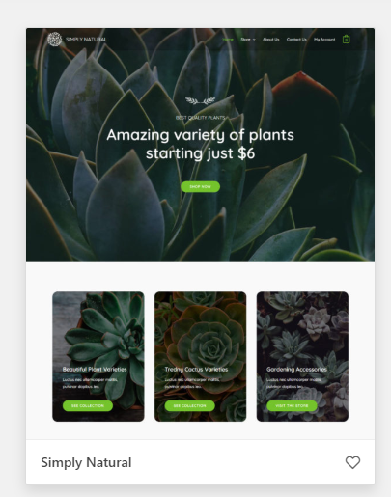

1. Importing The template

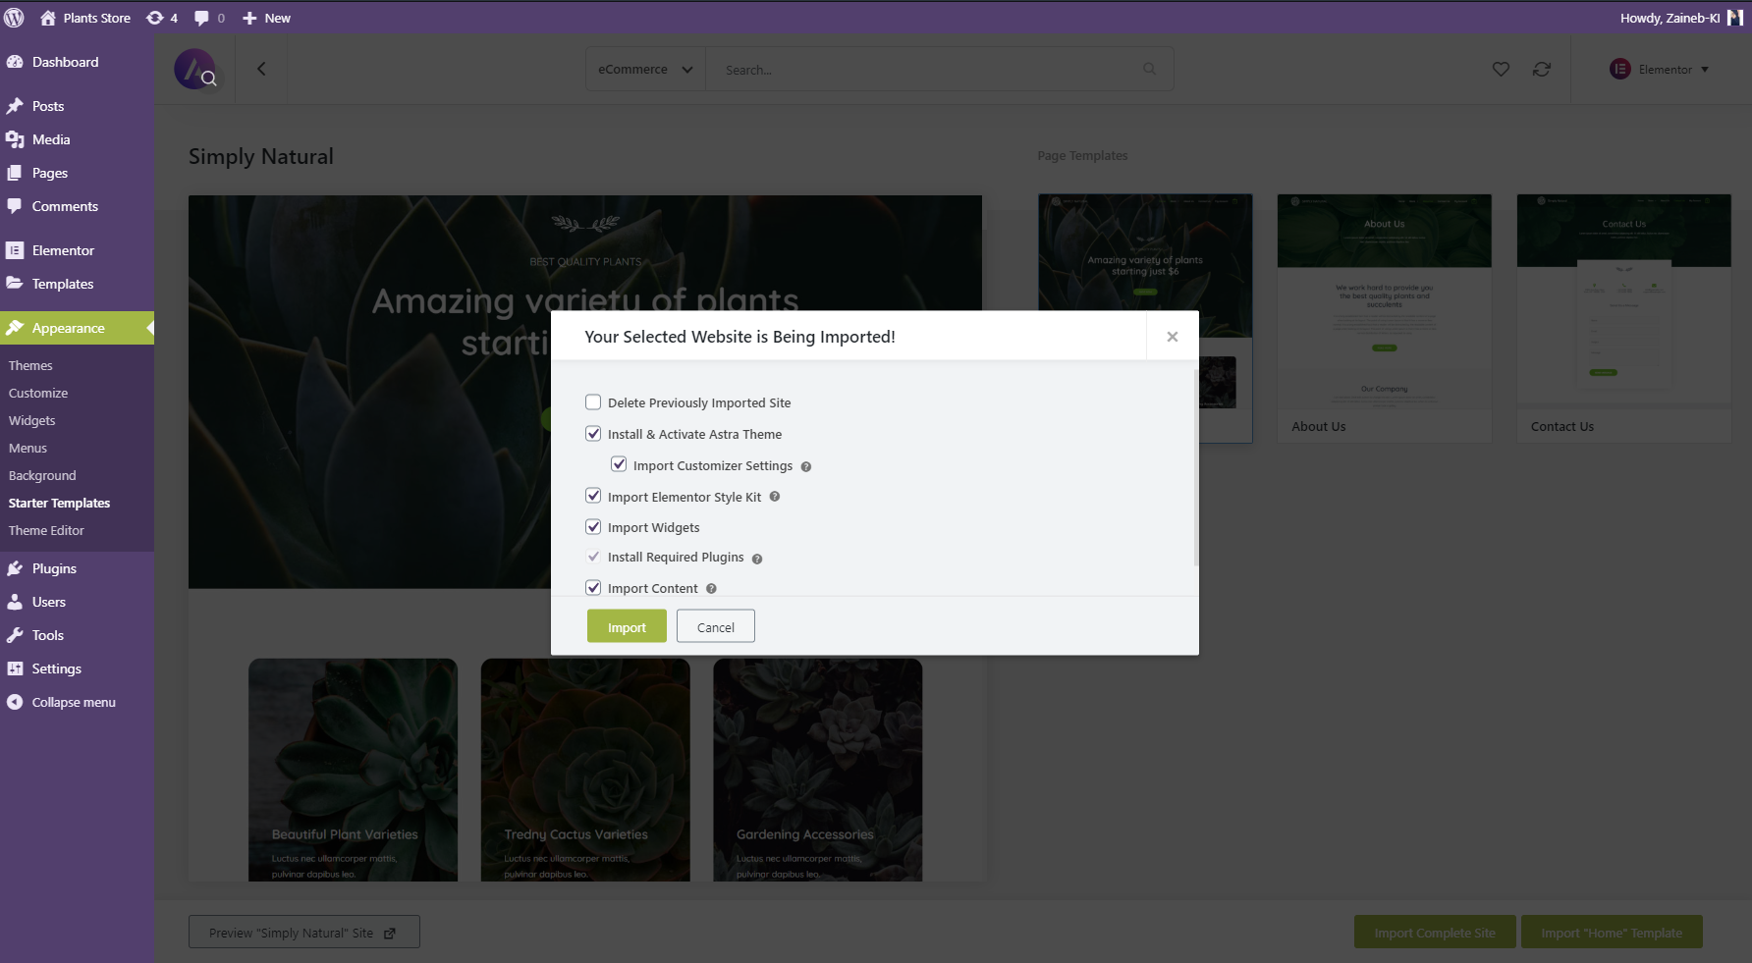





1. Now we’ll go to Appearance -> Menus for Update our Menu

